# Exercise: Simple and Complex Conditional Statements

Classroom and homework exercises for the course ["Programming-Fundamentals-and-Unit-Testing" @ SoftUni](https://softuni.bg/trainings/4256/programming-fundamentals-and-unit-testing-september-2023).

Test your solutions in the **judge system**: <https://judge.softuni.org/Contests/4400>

## Number Type

Write a program that:

* Reads **an integer number** from the console
* Based on the given number:
  + Print "**negative**", if the number **is lower than zero**
  + Print "**positive** ", if the number **is bigger than zero**
  + Print "**zero** ", if the number **is equals to zero**

### Example Input / Output

|  |  |  |  |  |  |  |  |
| --- | --- | --- | --- | --- | --- | --- | --- |
| **Input** | **Output** |  | **Input** | **Output** |  | **Input** | **Output** |
| 2 | positive | -1 | negative | 0 | zero |

## ATM

Write a program to **simulate an ATM withdrawal**:

* Reads **3 integer numbers** which represents the following values: **balance, withdraw** and **limit**
* Based on the given input parameters:
  + Print "**The withdraw was successful.**", if the balance **is enough**
  + Print "**The limit was exceeded.**", if the limit is exceeded
  + Print "**Insufficient availability.**", if the balance isn't enough

### Example Input / Output

|  |  |  |  |  |
| --- | --- | --- | --- | --- |
| **Input** | **Output** |  | **Input** | **Output** |
| 420  20  25 | The withdraw was successful. | 10  50  20 | The limit was exceeded. |

|  |  |  |  |  |
| --- | --- | --- | --- | --- |
| **Input** | **Output** |  | **Input** | **Output** |
| 10  20  30 | Insufficient availability. | 560  10  35 | The withdraw was successful. |

## Biggest of Five Numbers

Write a program to **find the biggest among 5 numbers**:

* Reads **5 integer numbers** from the console
* Print the biggest number from the given five

**Note:** There will not be equal numbers given.

### Example Input / Output

|  |  |  |  |  |
| --- | --- | --- | --- | --- |
| **Input** | **Output** |  | **Input** | **Output** |
| 1  2  3  4  5 | 5 | 10  50  20  30  40 | 50 |

## Number Operations

Write a program to **evaluate operations**, which:

* Reads **2 real numbers** and **math operator (string)** from the console
* Possible given values for the math operator are: **"+", "-", "*", "/"**
* Apply the operator with given numbers
* Print output in the following format, where **result** is formatted to the **second digit**:

**"{N1} {operator} {N2} = {result}"**

### Example Input / Output

|  |  |  |  |  |
| --- | --- | --- | --- | --- |
| **Input** | **Output** |  | **Input** | **Output** |
| 10  12  + | 10 + 12 = 22.00 | 22  9  - | 22 - 9 = 13.00 |

|  |  |  |  |  |
| --- | --- | --- | --- | --- |
| **Input** | **Output** |  | **Input** | **Output** |
| 7.6  8.2  * | 7.6 * 8.2 = 62.32 | 56  10  / | 56 / 10 = 5.60 |

## Vacation Expenses

Write a program, which **calculates vacation expenses**:

* From the console read: **season (string)**, **accommodation type (string)** and **count of the days (integer)**
  + **Season** will be one of the following: **"Spring", "Summer", "Autumn"** and **"Winter"**
  + **Accommodation type** will be one of the following: **"Hotel"** and **"Camping**
* Based on the table below, you **have to calculate expenses** for the vacation with the given **accommodation type, season** and **count of the days.**
* For the calculation:use **price per night (extracted from the table below) multiplied by count of the days.**
* Print the total expenses, formatted to the **second** **digit** after the decimal point

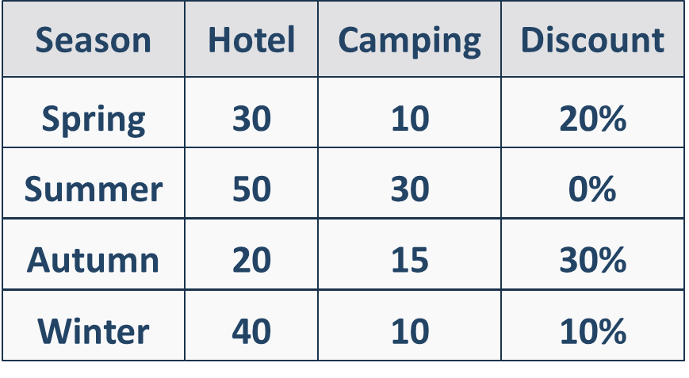

### Example Input / Output

|  |  |  |
| --- | --- | --- |
| **Input** | **Output** | **Comments** |
| Winter  Hotel  5 | 180.00 | Season is Winter, accommodation type is Hotel  Based on table, price per night is 40, and the discount is 10% or 0.10  Total expenses = 5 * 40 – 10% =200 – 10% = 180.00 |
| **Input** | **Output** | **Comments** |
| Summer  Camping  10 | 300.00 | Season is Summer, accommodation type is Camping  Based on table, price per night is 30, and the discount is 0%  Total expenses = 10 * 30 = 300 |

## Product of Three Numbers

Write a program that calculates the **sign of the product of three numbers**:

* Reads **3 real numbers** from the console
* Print the sign of the product of the three given numbers: **"positive"**, **"negative"** or **"zero"**

**Note:** Try to do this without multiplying the numbers.

### Example Input / Output

|  |  |  |  |  |  |  |  |
| --- | --- | --- | --- | --- | --- | --- | --- |
| **Input** | **Output** |  | **Input** | **Output** |  | **Input** | **Output** |
| 2  3  -1 | negative | -3  -4  5 | positive | 0  4  5 | zero |

## Working Hours

Write a program that **checks if the company's office is open**:

* Reads **an hour of the day (integer number)** and **a day of the week (string)**
* The office's **working hours are from 10 AM to 6 PM, Monday through Saturday**, inclusive**.**
  + Print **"open"**, **if the office is open in the given hour and day of the week**
  + Print **"closed"**, **if the office is closed in the given hour and day of the week**

### Example Input / Output

|  |  |  |  |  |  |  |  |
| --- | --- | --- | --- | --- | --- | --- | --- |
| **Input** | **Output** |  | **Input** | **Output** |  | **Input** | **Output** |
| 11  Monday | open | 19  Friday | closed | 11  Sunday | closed |

## Invalid Number

### A given number is valid if it is in the range [100...200] or it is equals to 0.

### Write a program that:

### Reads an integer from the console

### Prints "invalid" if the entered number is NOT valid

### Example Input / Output

|  |  |  |  |  |  |  |  |
| --- | --- | --- | --- | --- | --- | --- | --- |
| **Input** | **Output** |  | **Input** | **Output** |  | **Input** | **Output** |
| 75 | invalid | 150 | *(няма изход)* | 0 | *(няма изход)* |

## Sum Seconds

Three athletes finish in a certain number of seconds (between 1 and 50).

Write a program that:

* Read **three integers - the athletes' times in seconds**, from console
* Calculate their total time in the format **"minutes:seconds"**

**Note**: The seconds should be displayed **with leading zero** (2 as "02", 7 as "07", 35 as "35").

### Example Input / Output

|  |  |  |  |  |  |  |  |
| --- | --- | --- | --- | --- | --- | --- | --- |
| **Input** | **Output** |  | **Input** | **Output** |  | **Input** | **Output** |
| 35  45  44 | 2:04 | 22  7  34 | 1:03 | 50  50  49 | 2:29 |

## Summer Outfit

Summer weather can be quite unpredictable, and Victor needs your assistance. Write a program that, **based on the time of day** and the **temperature**, recommends to Victor **what clothes to wear**. Your friend has **different plans for each stage of the day** that require varied clothing, as indicated in the table.

**Two lines are read from the console:**

* **Temperature - an integer in the range [10... 42]**
* **Text, time of day - with possibilities - "Morning", "Afternoon", "Evening"**

|  |  |  |  |
| --- | --- | --- | --- |
| **Time of day / degrees** | Morning | Afternoon | Evening |
| 10 <= temperature <= 18 | Clothing = Sweatshirt  Shoes = Sneakers | Clothing = Shirt  Shoes = Moccasins | Clothing = Shirt  Shoes = Moccasins |
| 18 < temperature <= 24 | Clothing = Shirt  Shoes = Moccasins | Clothing = T-Shirt  Shoes = Sandals | Clothing = Shirt  Shoes = Moccasins |
| temperature >= 25 | Clothing = T-Shirt  Shoes = Sandals | Clothing = Swim Suit  Shoes = Barefoot | Clothing = Shirt  Shoes = Moccasins |

**Print on the console on a single line: "It's {temperature} degrees, get your {clothing} and {shoes}."**

### Example Input/Output

|  |  |  |  |
| --- | --- | --- | --- |
| **Input** | **Output** | **Comments** | |
| 16  Morning | It's 16 degrees, get your Sweatshirt and Sneakers. | In the morning, when the degrees are 16, Victor takes a sweatshirt and sneakers. | |
| **Input** | **Output** | **Input** | **Output** |
| 22  Afternoon | It's 22 degrees, get your T-Shirt and Sandals. | 28  Evening | It's 28 degrees, get your Shirt and Moccasins. |

### Guidelines

1. Read the **input data from the console** and initialize two variables **outfit** and **shoes** of type **"string"**, with initial value **""**.

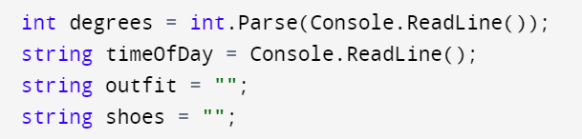

1. Check the temperature using **logical operator "and" (&&)**. Example: **"degrees** >= 10 && degrees <= 18**"** Within the temperature check, consider the time of the day: Morning, Afternoon, Evening by changing the value of the variables "outfit, shoes" **for each stage of the day**.

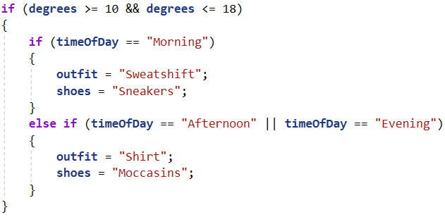

1. Print the result on the console following the format outlined in the task description.

